**AIM:**

# WEEK-1

1. Install the required software’s and configure the system to develop the android

applications.

**PROCEDURE:**

**Android Studio** is the official **IDE (Integrated Development Environment)** for Android app development and it is based on **JetBrains’ IntelliJ IDEA** software.

System requirements:

* + Microsoft Windows 7/8/10 (32-bit or 64-bit)
  + 4 GB RAM minimum, 8 GB RAM recommended (plus 1 GB for the Android Emulator)
  + 2 GB of available disk space minimum, 4 GB recommended (500 MB for IDE plus 1.5 GB for Android SDK and emulator system image)
  + 1280 x 800 minimum screen resolution.

**Installation:**

**Step 1:** Click on the **Download Android Studio** Button.

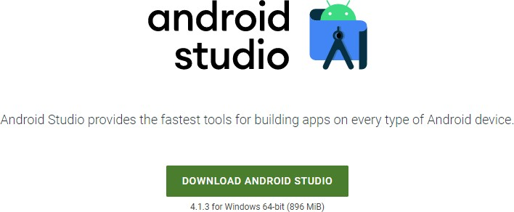

Step 2: Click on the “I have read and agree with the above terms and conditions” checkbox

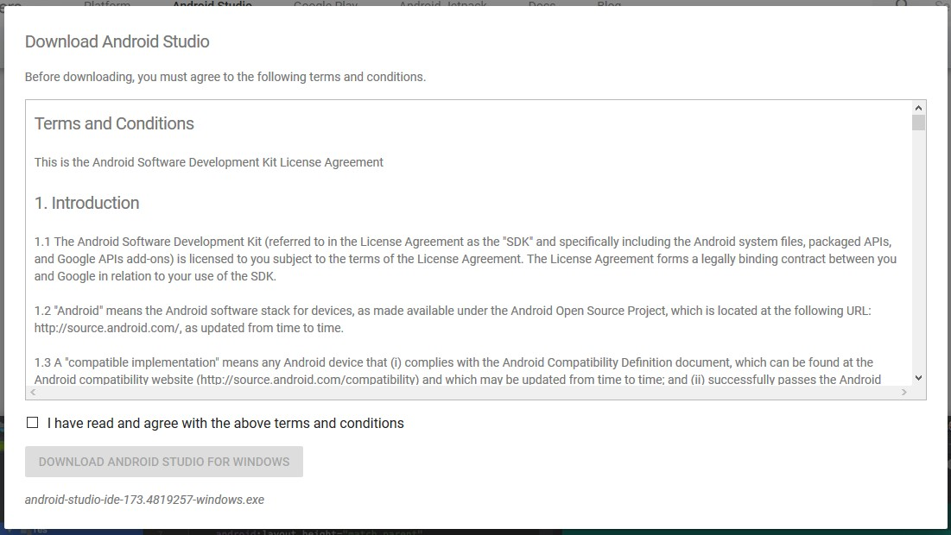followed by the download button.

Click on the Save file button in the appeared prompt box and the file will start downloading.

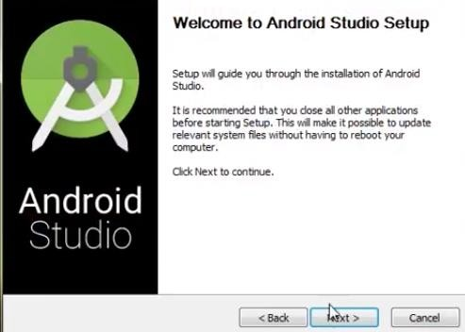**Step 3:** After the downloading has finished, open the file from downloads and run it. It will prompt the following dialog box.

Click on next. In the next prompt, it’ll ask for a path for installation. Choose a path and hit

next.

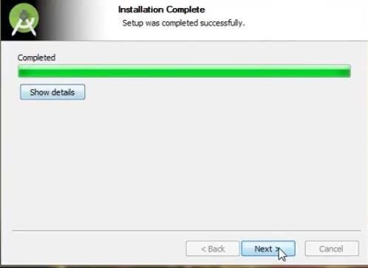**Step 4:** It will start the installation, and once it is completed, it will be like the image shown below.

Click on next.

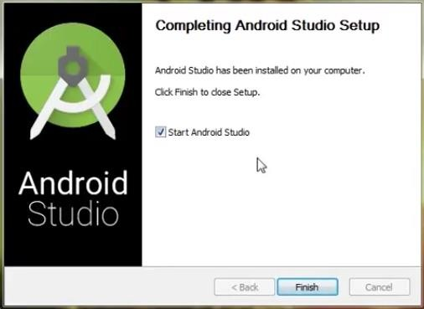

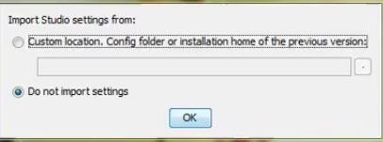**Step 5:** Once “**Finish**” is clicked, it will ask whether the previous settings need to be imported [if the android studio had been installed earlier], or not. It is better to choose the ‘Don’t import Settings option’.

Click the **OK** button.

**Step 6:** This will start the Android Studio.

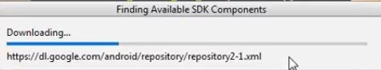Meanwhile, it will be finding the available SDK components.

**Step 7:** After it has found the SDK components, it will redirect to the Welcome dialog box.

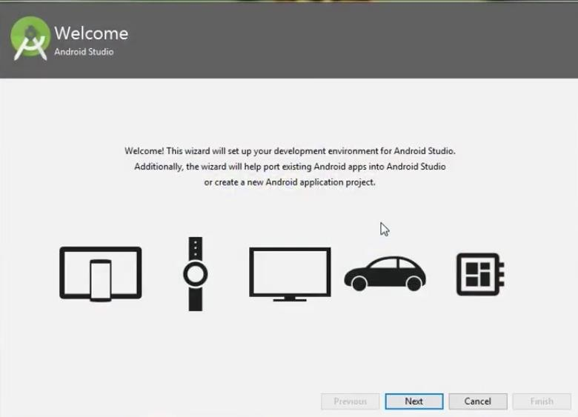

Click on **Next**.

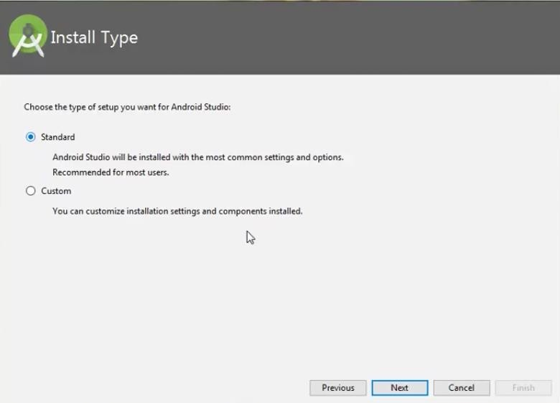

Choose Standard and click on Next. Now choose the theme, whether the **Light** theme or the **Dark** one. The light one is called the **IntelliJ** theme whereas the dark theme is

called **Darcula**. Choose as required.

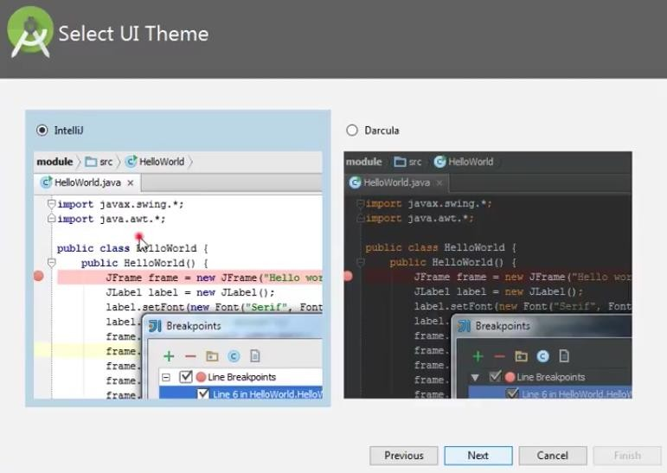

Click on the **Next** button.

**Step 8:** Now it is time to download the SDK components.

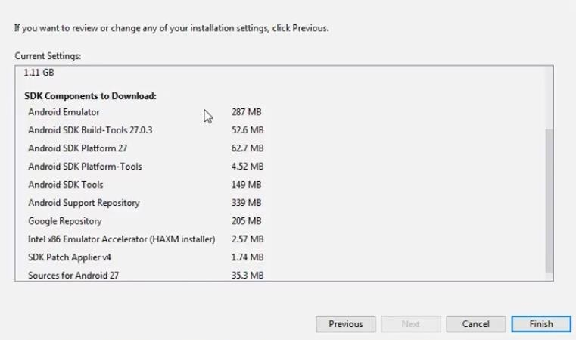

Click on Finish. Components begin to download let it complete.

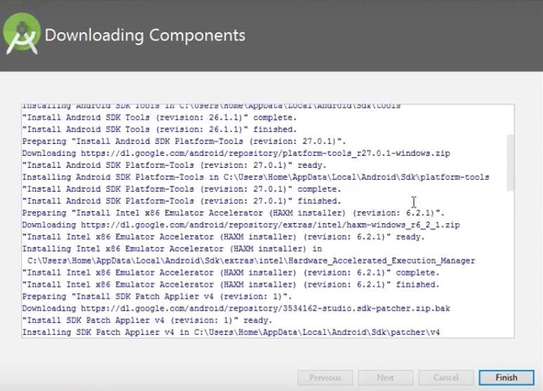

The Android Studio has been successfully configured. Now it’s time to launch and build

apps. Click on the Finish button to launch it.

**Step 9:** Click on **Start a new Android Studio project** to build a new app.

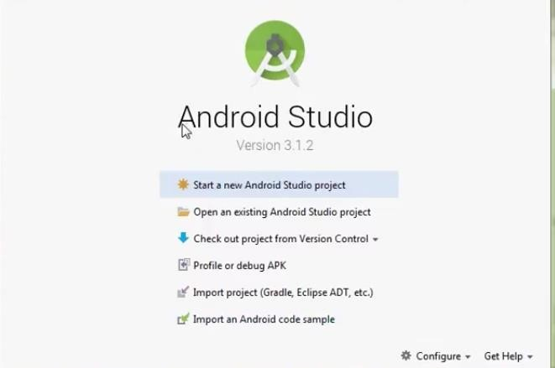

RESULT:

Android studio has been successfully configured.

**AIM:**

# WEEK-2

1. Develop an application that uses GUI components, Font and Colors.

**PROGRAM:**

## Activity_main.xml:

*<?*xml version="1.0" encoding="utf-8"*?>*<LinearLayout xmlns:android="http://schemas.android.com/apk/res/android"  
 android:orientation="vertical"  
 android:layout_width="match_parent"  
 android:layout_height="match_parent">  
  
 <TextView  
 android:id="@+id/textView"  
 android:layout_width="match_parent"  
 android:layout_height="wrap_content"  
 android:layout_margin="30dp"  
 android:gravity="center"  
 android:text="Week 2"  
 android:textSize="25sp"  
 android:textStyle="bold" />  
  
 <Button  
 android:id="@+id/button1"  
 android:layout_width="match_parent"  
 android:layout_height="wrap_content"  
 android:layout_margin="20dp"  
 android:gravity="center"  
 android:text="Change font size"  
 android:textSize="25sp" />  
 <Button  
 android:id="@+id/button2"  
 android:layout_width="match_parent"  
 android:layout_height="wrap_content"  
 android:layout_margin="20dp"  
 android:gravity="center"  
 android:text="Change color"  
 android:textSize="25sp" />  
</LinearLayout>

## MainActivity.java:

package com.example.week2;  
import android.graphics.Color;  
import android.os.Bundle;  
import android.view.View;  
import android.widget.*;  
import androidx.appcompat.app.AppCompatActivity;  
  
public class MainActivity extends AppCompatActivity  
{  
 int ch=1;  
 float font=30;  
 @Override  
 protected void onCreate(Bundle savedInstanceState)  
 {  
 super.onCreate(savedInstanceState);  
 setContentView(R.layout.*activity_main*);  
 final TextView t= (TextView) findViewById(R.id.*textView*);  
 Button b1= (Button) findViewById(R.id.*button1*);  
 b1.setOnClickListener(new View.OnClickListener() {  
 @Override  
 public void onClick(View v) {  
 t.setTextSize(font);  
 font = font + 5;  
 if (font == 50)  
 font = 30;  
 }  
 });  
 Button b2= (Button) findViewById(R.id.*button2*);  
 b2.setOnClickListener(new View.OnClickListener() {  
 @Override  
 public void onClick(View v) {  
 switch (ch) {  
 case 1:t.setTextColor(Color.*RED*);break;  
 case 2:t.setTextColor(Color.*GREEN*);break;  
 case 3:t.setTextColor(Color.*BLUE*);break;  
 case 4:t.setTextColor(Color.*CYAN*);break;  
 case 5:t.setTextColor(Color.*YELLOW*);break;  
 case 6:t.setTextColor(Color.*MAGENTA*);break;  
 default: ch = 1;break;  
 }  
 ch++;  
 }  
 });  
 }  
}

**OUTPUT:**

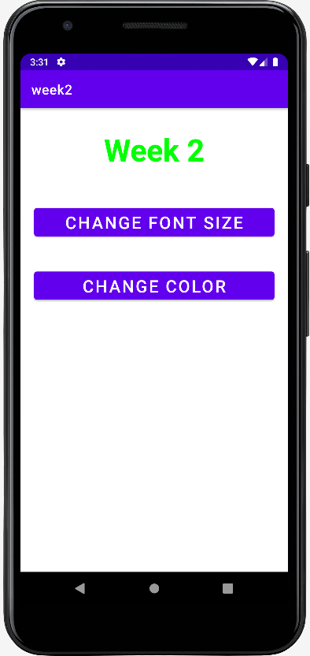 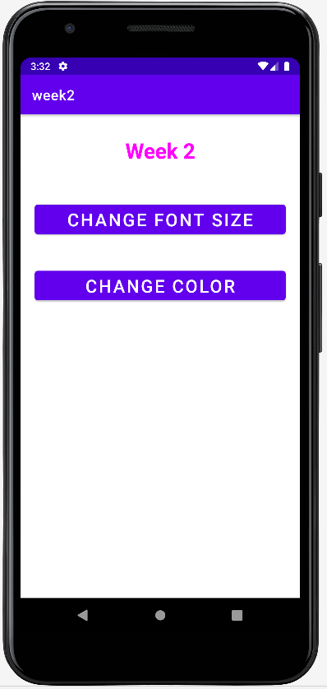

**RESULT:**

Android Application that uses GUI components, Font and Colors is developed and executed successfully.

**AIM:**

# WEEK-3

1. Develop a basic calculator application that uses Layout Managers and event listeners.

**PROGRAM:**

## Activity_main.xml:

*<?*xml version="1.0" encoding="utf-8"*?>*<LinearLayout  
 xmlns:android = "http://schemas.android.com/apk/res/android"  
 android:layout_width="match_parent"  
 android:layout_height="match_parent"  
 android:layout_margin="20dp"  
 android:orientation="vertical">  
 <LinearLayout  
 android:id = "@+id/linearLayout1"  
 android:layout_margin="20dp"  
 android:layout_width="match_parent"  
 android:layout_height="wrap_content"  
 android:orientation="horizontal">  
 <EditText  
 android:id="@+id/editText1"  
 android:layout_width="match_parent"  
 android:layout_height="wrap_content"  
 android:layout_weight="1"  
 android:inputType="numberDecimal"  
 android:textSize="20sp">  
  
 </EditText>  
 <EditText  
 android:id="@+id/editText2"  
 android:layout_width="match_parent"  
 android:layout_height="wrap_content"  
 android:layout_weight="1"  
 android:inputType="numberDecimal"  
 android:textSize="20sp">  
  
 </EditText>  
 </LinearLayout>  
  
 <LinearLayout  
 android:id="@+id/linearLayout2"  
 android:layout_width="match_parent"  
 android:layout_height="wrap_content"  
 android:layout_margin="20dp">  
 <Button  
 android:id="@+id/add"  
 android:layout_width="match_parent"  
 android:layout_height="wrap_content"  
 android:layout_weight="1"  
 android:layout_margin="1dp"  
 android:text="+"  
 android:textSize="30sp" />  
 <Button  
 android:id="@+id/sub"  
 android:layout_width="match_parent"  
 android:layout_margin="1dp"  
 android:layout_height="wrap_content"  
 android:layout_weight="1"  
 android:text="-"  
 android:textSize="30sp" />  
 <Button  
 android:layout_margin="1dp"  
 android:id="@+id/mul"  
 android:layout_width="match_parent"  
 android:layout_height="wrap_content"  
 android:layout_weight="1"  
 android:text="*"  
 android:textSize="30sp" />  
 <Button  
 android:id="@+id/div"  
 android:layout_width="match_parent"  
 android:layout_margin="1dp"  
 android:layout_height="wrap_content"  
 android:layout_weight="1"  
 android:text="/"  
 android:textSize="30sp" />  
 </LinearLayout>  
  
 <TextView  
 android:id="@+id/textView"  
 android:layout_width="match_parent"  
 android:layout_height="wrap_content"  
 android:layout_marginTop="50dp"  
 android:text="Answer is : "  
 android:textSize="30sp"  
 android:layout_gravity="center"/>  
</LinearLayout>

## MainActivity.java:

package com.example.week3;  
import androidx.appcompat.app.AppCompatActivity;  
import android.text.TextUtils;  
import android.view.*;  
import android.view.View.OnClickListener;  
import android.widget.*;  
import android.os.Bundle;  
  
public class MainActivity extends AppCompatActivity implements OnClickListener {  
  
 EditText num1, num2;  
 Button add,sub,mul,div;  
 TextView result;  
 @Override  
 protected void onCreate(Bundle savedInstanceState) {  
 super.onCreate(savedInstanceState);  
 setContentView(R.layout.*activity_main*);  
 num1 = (EditText)findViewById(R.id.*editText1*);  
 num2 = (EditText)findViewById(R.id.*editText2*);  
 add = (Button)findViewById(R.id.*add*);  
 sub = (Button)findViewById(R.id.*sub*);  
 mul = (Button)findViewById(R.id.*mul*);  
 div = (Button)findViewById(R.id.*div*);  
 result = (TextView) findViewById(R.id.*textView*);  
  
 add.setOnClickListener(this);  
 sub.setOnClickListener(this);  
 mul.setOnClickListener(this);  
 div.setOnClickListener(this);  
 }  
 @Override  
 public void onClick(View v){  
 float Num1 = 0 , Num2 = 0 , Result = 0;  
 String oper = new String();  
 if(TextUtils.*isEmpty*(num1.getText().toString())||TextUtils.*isEmpty*(num2.getText().toString()))  
 return;  
 Num1 = Float.*parseFloat*(num1.getText().toString());  
 Num2 = Float.*parseFloat*(num2.getText().toString());  
 switch(v.getId()){  
 case R.id.*add*:  
 oper = "+";  
 Result = Num1 + Num2;  
 break;  
 case R.id.*sub*:  
 oper = "-";  
 Result = Num1 - Num2;  
 break;  
 case R.id.*mul*:  
 oper = "*";  
 Result = Num1 * Num2;  
 break;  
 case R.id.*div*:  
 oper = "/";  
 Result = Num1 / Num2;  
 break;  
 default:  
 break;  
 }  
 result.setText(Num1+" "+oper+" "+Num2+" = "+Result);  
 }  
}

OUTPUT:

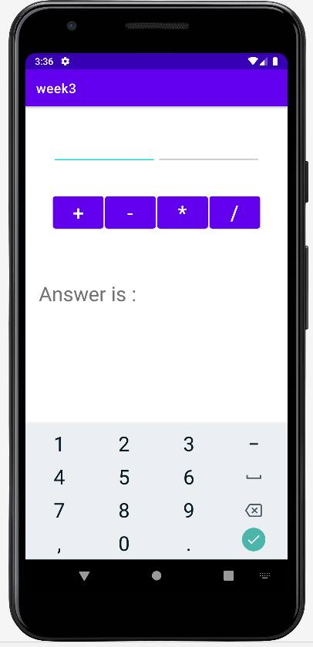 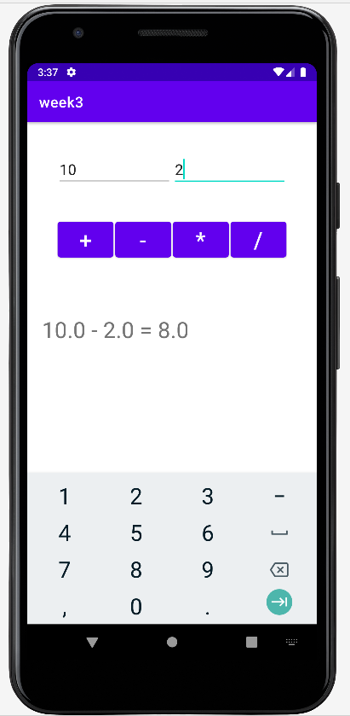

**RESULT:**

Simple Android Application for basic calculator that uses Layout Managers and event listeners is developed and executed successfully.

**AIM:**

# WEEK-4

**WEEK - 5**

**Aim:**

1. Develop an application that makes use of databases to maintain the student marks.

**PROGRAM:**

## Activity_main.xml:

*<?*xml version="1.0" encoding="utf-8"*?>*<AbsoluteLayout  
 xmlns:android = "http://schemas.android.com/apk/res/android"  
 android:layout_width="match_parent"  
 android:layout_height="match_parent">  
 <TextView  
 android:layout_width="wrap_content"  
 android:layout_height="wrap_content"  
 android:layout_x="90dp"  
 android:layout_y="20sp"  
 android:text="Student Details"  
 android:textSize="30sp" />  
  
 <TextView  
 android:layout_width="wrap_content"  
 android:layout_height="wrap_content"  
 android:layout_x="20dp"  
 android:layout_y="105dp"  
 android:text="Enter RollNo : "  
 android:textSize="20sp" />  
  
 <EditText  
 android:id="@+id/roll"  
 android:layout_width="175dp"  
 android:layout_height="wrap_content"  
 android:layout_x="185dp"  
 android:layout_y="90dp" />  
  
 <TextView  
 android:layout_width="wrap_content"  
 android:layout_height="wrap_content"  
 android:layout_x="20dp"  
 android:layout_y="167dp"  
 android:text="Enter Name : "  
 android:textSize="20sp" />  
  
 <EditText  
 android:id="@+id/name"  
 android:layout_width="175dp"  
 android:layout_height="wrap_content"  
 android:layout_x="185dp"  
 android:layout_y="150dp" />  
  
 <TextView  
 android:layout_width="wrap_content"  
 android:layout_height="wrap_content"  
 android:layout_x="20dp"  
 android:layout_y="233dp"  
 android:text="Enter Marks : "  
 android:textSize="20sp" />  
  
 <EditText  
 android:id="@+id/marks"  
 android:layout_width="175dp"  
 android:layout_height="wrap_content"  
 android:layout_x="185dp"  
 android:layout_y="216dp" />  
  
 <Button  
 android:id="@+id/insert"  
 android:layout_width="360dp"  
 android:layout_height="wrap_content"  
 android:layout_x="22dp"  
 android:layout_y="303dp"  
 android:text="Insert"  
 android:textAlignment="center"  
 android:textSize="25sp" />  
  
 <Button  
 android:id="@+id/delete"  
 android:layout_width="356dp"  
 android:layout_height="wrap_content"  
 android:layout_x="22dp"  
 android:layout_y="374dp"  
 android:text="Delete"  
 android:textAlignment="center"  
 android:textSize="25sp" />  
  
 <Button  
 android:id="@+id/update"  
 android:layout_width="356dp"  
 android:layout_height="wrap_content"  
 android:layout_x="22dp"  
 android:layout_y="446dp"  
 android:text="Update"  
 android:textAlignment="center"  
 android:textSize="25sp" />  
  
 <Button  
 android:id="@+id/view"  
 android:layout_width="356dp"  
 android:layout_height="wrap_content"  
 android:layout_x="22dp"  
 android:layout_y="525dp"  
 android:text="View"  
 android:textAlignment="center"  
 android:textSize="25sp" />  
  
 <Button  
 android:id="@+id/viewall"  
 android:layout_width="356dp"  
 android:layout_height="wrap_content"  
 android:layout_x="24dp"  
 android:layout_y="605dp"  
 android:text="View All"  
 android:textAlignment="center"  
 android:textSize="25sp" />  
</AbsoluteLayout>

**MainActivity.java:**

package com.example.week4;  
  
import androidx.appcompat.app.AppCompatActivity;  
import android.app.AlertDialog.*;  
import android.content.Context;  
import android.database.Cursor;  
import android.database.sqlite.SQLiteDatabase;  
import android.view.View.OnClickListener;  
import android.view.*;  
import android.os.Bundle;  
import android.widget.*;  
public class MainActivity extends AppCompatActivity implements OnClickListener{  
 EditText RollNo ,Name , Marks;  
 Button insert ,delete, update , view , viewAll;  
 SQLiteDatabase db;  
 @Override  
 protected void onCreate(Bundle savedInstanceState) {  
 super.onCreate(savedInstanceState);  
 setContentView(R.layout.*activity_main*);  
 RollNo = (EditText) findViewById(R.id.*roll*);  
 Name = (EditText) findViewById(R.id.*name*);  
 Marks = (EditText) findViewById(R.id.*marks*);  
 insert = (Button) findViewById(R.id.*insert*);  
 delete = (Button) findViewById(R.id.*delete*);  
 update = (Button) findViewById(R.id.*update*);  
 view = (Button) findViewById(R.id.*view*);  
 viewAll = (Button) findViewById(R.id.*viewall*);  
  
 insert.setOnClickListener(this);  
 delete.setOnClickListener(this);  
 update.setOnClickListener(this);  
 view.setOnClickListener(this);  
 viewAll.setOnClickListener(this);  
  
 db = openOrCreateDatabase("StudentDB", Context.*MODE_PRIVATE*,null);  
 db.execSQL("create table if not exists student(rollNo varchar(20),name varchar(20),marks varchar(20));");  
 }  
 @Override  
 public void onClick(View v){  
 if(v.getId() == R.id.*insert*){  
 if(RollNo.getText().toString().trim().length() == 0||  
 Name.getText().toString().trim().length() == 0||  
 Marks.getText().toString().trim().length() == 0){  
 showMessage("Error","Please Enter All the Fields");  
 return;  
 }  
 db.execSQL("insert into student values ('"+RollNo.getText()+"','"+Name.getText()+  
 "','"+Marks.getText()+"');");  
 showMessage("Success" , "Added Records Succesfully");  
 clearText();  
 }  
 if(v.getId() == R.id.*delete*){  
 if(RollNo.getText().toString().trim().length() == 0){  
 showMessage("Error","Please Enter Roll No");  
 return;  
 }  
 Cursor c = db.rawQuery("select * from student where rollNo = '"+RollNo.getText().toString()+"'",null);  
 if(c.moveToFirst()){  
 db.execSQL("delete from student where rollNo = '"+RollNo.getText().toString()+"'");  
 showMessage("Deleted","Successfully Deleted");  
 }  
 else  
 showMessage("Error","Record Not Found");  
 clearText();  
 }  
 if(v.getId()==R.id.*update*)  
 {  
 if(RollNo.getText().toString().trim().length()==0){  
 showMessage("Error", "Please enter Rollno");  
 return;  
 }  
 Cursor c=db.rawQuery("SELECT * FROM student WHERE rollNo='"+RollNo.getText()+"'", null);  
 if(c.moveToFirst()) {  
 db.execSQL("UPDATE student SET name='" + Name.getText() + "',marks='" + Marks.getText() +  
 "' WHERE rollNo='"+RollNo.getText()+"'");  
 showMessage("Updated", "Record Modified");  
 }  
 else showMessage("Error", "Invalid Rollno");  
 clearText();  
 }  
 if(v.getId()==R.id.*view*)  
 {  
 if(RollNo.getText().toString().trim().length()==0){  
 showMessage("Error", "Please enter Rollno");  
 return;  
 }  
 Cursor c=db.rawQuery("SELECT * FROM student WHERE rollNo='"+RollNo.getText()+"'", null);  
 if(c.moveToFirst()){  
 Name.setText(c.getString(1));  
 Marks.setText(c.getString(2));  
 }  
 else {  
 showMessage("Error", "Invalid Rollno");  
 clearText();  
 }  
 }  
 if(v.getId()==R.id.*viewall*) {  
 Cursor c=db.rawQuery("SELECT * FROM student", null);  
 if(c.getCount()==0){  
 showMessage("Error", "No records found");  
 return;  
 }  
 StringBuffer buffer=new StringBuffer();  
 c.moveToFirst();  
 while(c.moveToNext()){  
 buffer.append("Rollno: "+c.getString(0)+"\n");  
 buffer.append("Name: "+c.getString(1)+"\n");  
 buffer.append("Marks: "+c.getString(2)+"\n\n");  
 }  
 showMessage("Student Details", buffer.toString());  
 }  
 }  
 public void showMessage(String title, String message){  
 Builder builder = new Builder(this);  
 builder.setCancelable(true);  
 builder.setTitle(title);  
 builder.setMessage(message);  
 builder.show();  
 }  
 public void clearText(){  
 RollNo.setText("");  
 Name.setText("");  
 Marks.setText("");  
 }  
}

**OUTPUT:**

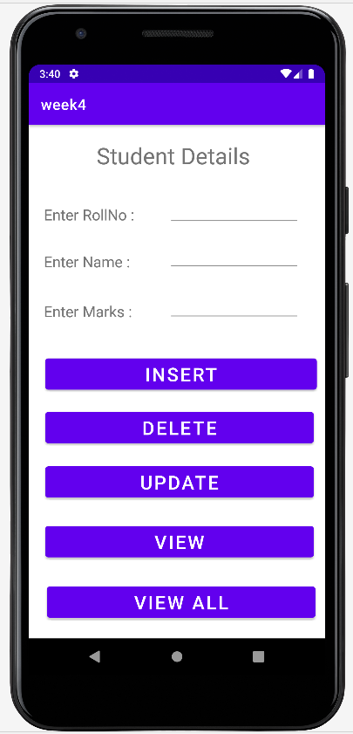 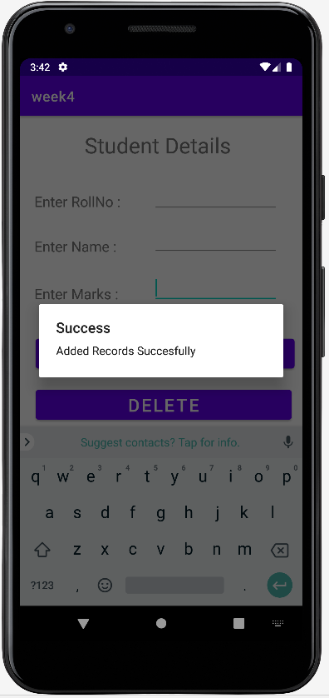 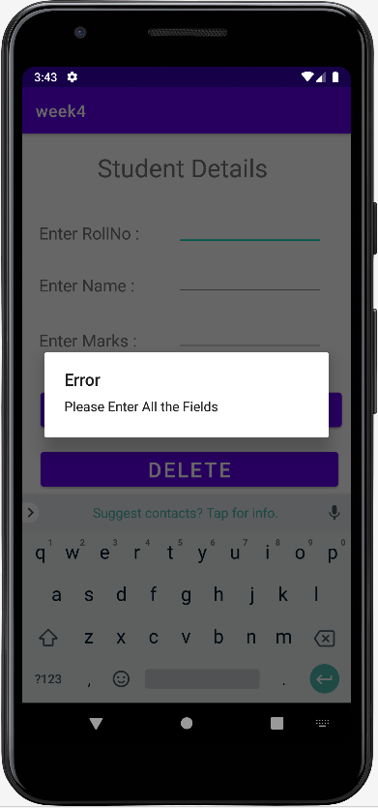

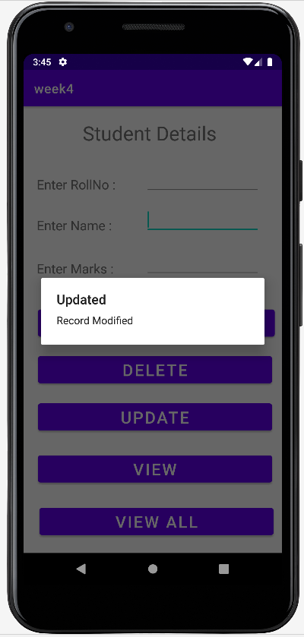 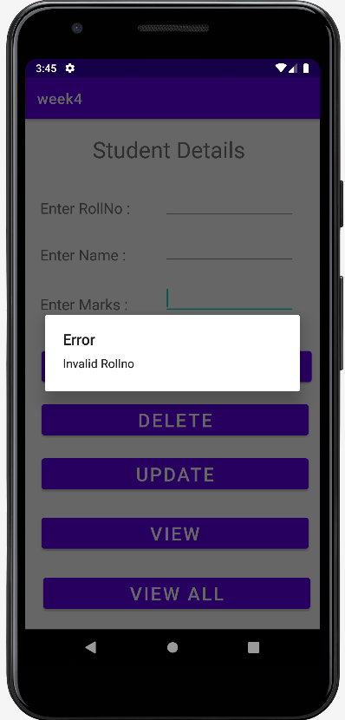 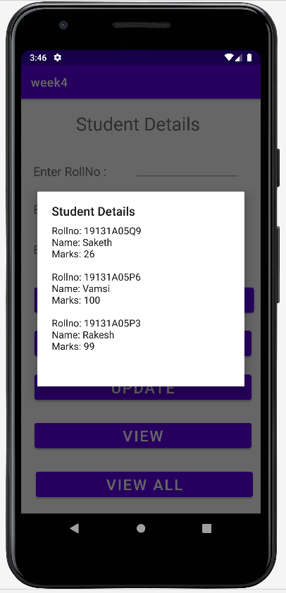

RESULT:

Android application that makes use of Database is developed and executed successfully.

**AIM:**

# WEEK-5

1. Develop an application that makes use of Notification Manager

**PROGRAM:**

## Activity_main.xml:

*<?*xml version="1.0" encoding="utf-8"*?>*<AbsoluteLayout  
 xmlns:android = "http://schemas.android.com/apk/res/android"  
 android:layout_width = "match_parent"  
 android:layout_height = "match_parent">  
  
 <Button  
 android:id="@+id/notify"  
 android:layout_width="251dp"  
 android:layout_height="105dp"  
 android:layout_x="81dp"  
 android:layout_y="299dp"  
 android:text="Get Notificatin" />  
</AbsoluteLayout>

## MainActivity.java:

package com.example.week5;  
  
import androidx.appcompat.app.AppCompatActivity;  
import androidx.core.app.NotificationCompat;  
import androidx.core.app.NotificationManagerCompat;  
  
import android.app.NotificationChannel;  
import android.app.NotificationManager;  
import android.os.Build;  
import android.view.View;  
import android.widget.*;  
import android.os.Bundle;  
  
public class MainActivity extends AppCompatActivity implements View.OnClickListener{  
 Button notify;  
 @Override  
 protected void onCreate(Bundle savedInstanceState) {  
 super.onCreate(savedInstanceState);  
 setContentView(R.layout.*activity_main*);  
 if(Build.VERSION.*SDK_INT* >= Build.VERSION_CODES.*O*){  
 NotificationChannel channel = new NotificationChannel("My Notification" , "My Notification" , NotificationManager.*IMPORTANCE_DEFAULT*);  
 NotificationManager manager = getSystemService(NotificationManager.class);  
 manager.createNotificationChannel(channel);  
 }  
 notify = (Button) findViewById(R.id.*notify*);  
 notify.setOnClickListener(this);  
 }  
 @Override  
 public void onClick(View v){  
 if(v.getId() == R.id.*notify*){  
 NotificationCompat.Builder builder = new NotificationCompat.Builder(MainActivity.this,"My Notification");  
 builder.setContentTitle("Week 5");  
 builder.setContentText("Successfully completed Week 5");  
 builder.setSmallIcon(R.drawable.*ic_launcher_background*);  
 builder.setAutoCancel(true);  
  
 NotificationManagerCompat manager = NotificationManagerCompat.*from*(MainActivity.this);  
 manager.notify(1, builder.build());  
 }  
 }  
}

**OUTPUT:**

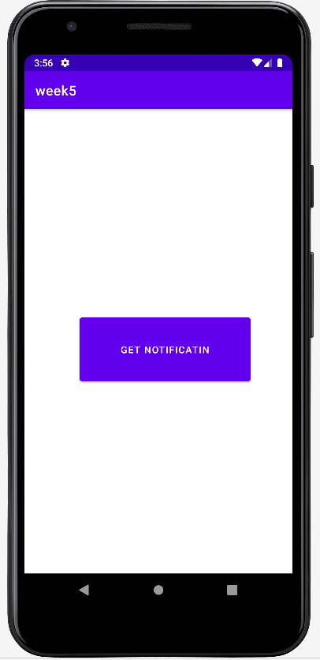 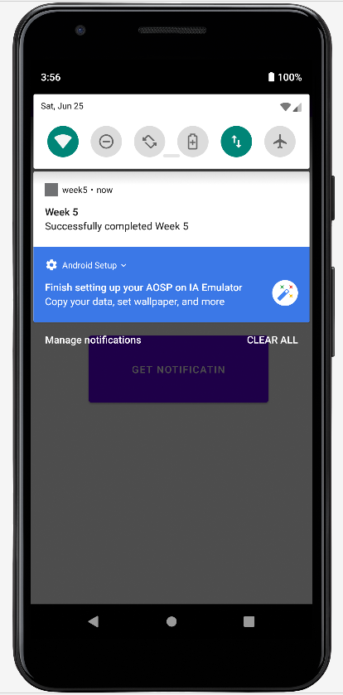

**RESULT:**

Android Application that uses Notification Manager is developed and excecuted successfuly.